**Drawing ERD’S To Represent Entities And Their Relationships**

**1. My Initial ERD**

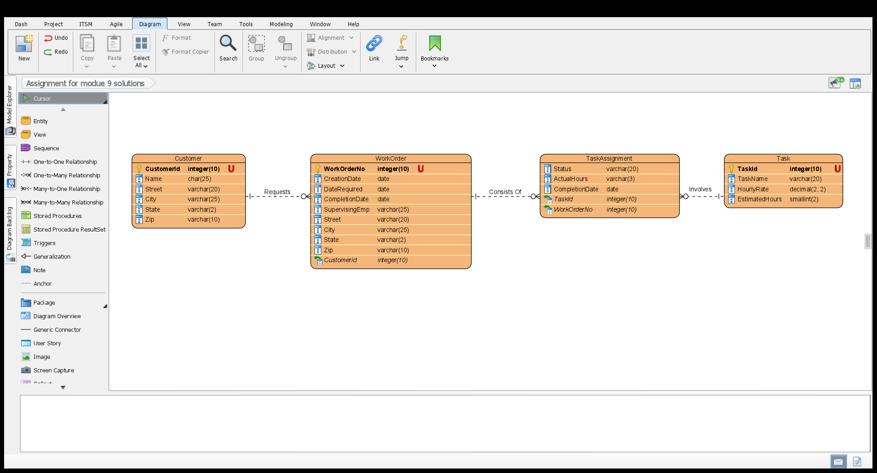

**2. ERD After Revisions Are Made**

